# ORDER and CHAOS Assignment

# |Harmanjot Singh Grewal | 16PH20015

## All Plots have been made in Matlab

## 6.1.9

Dipole Fixed Point Plot. All vectors have been normalized for better clarity

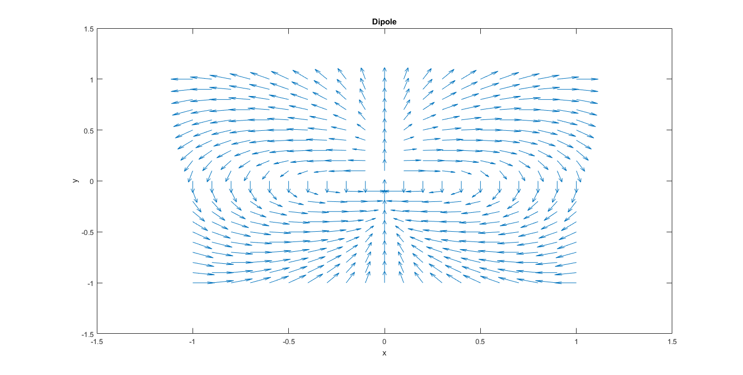

## 6.1.10

Two eyed monster

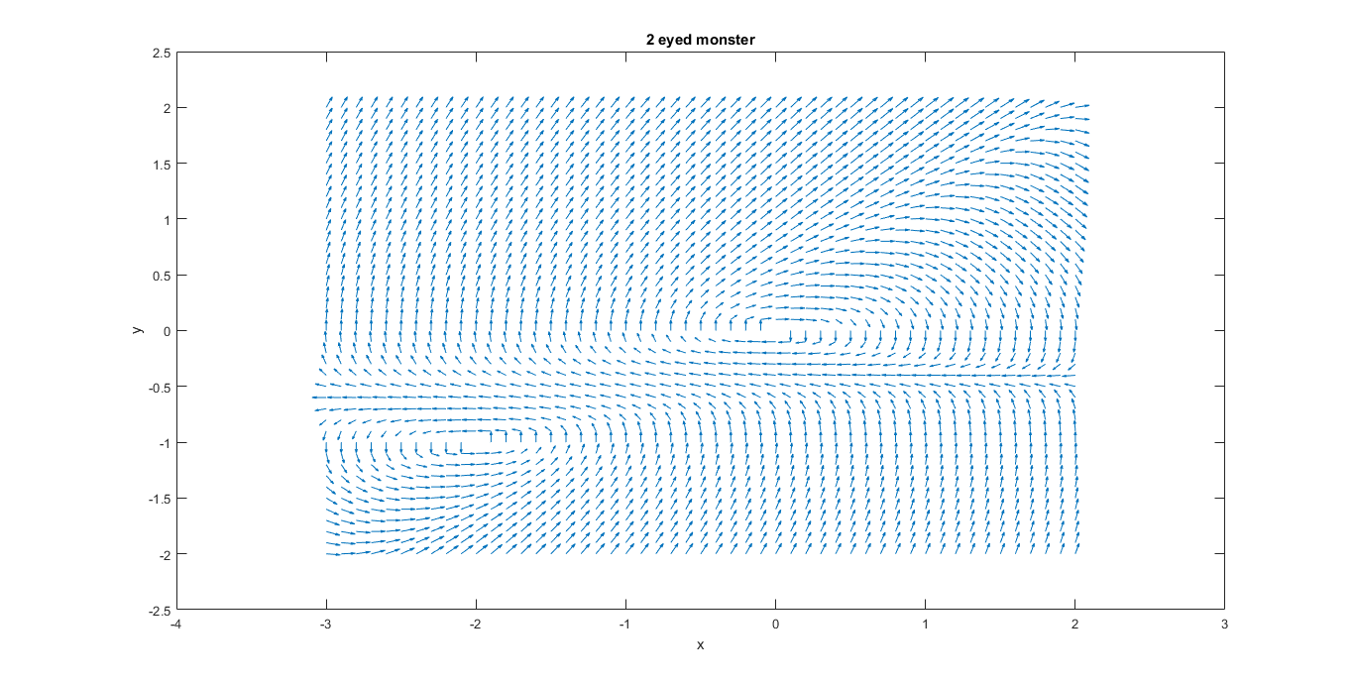

## 6.1.10 and 6.3.1

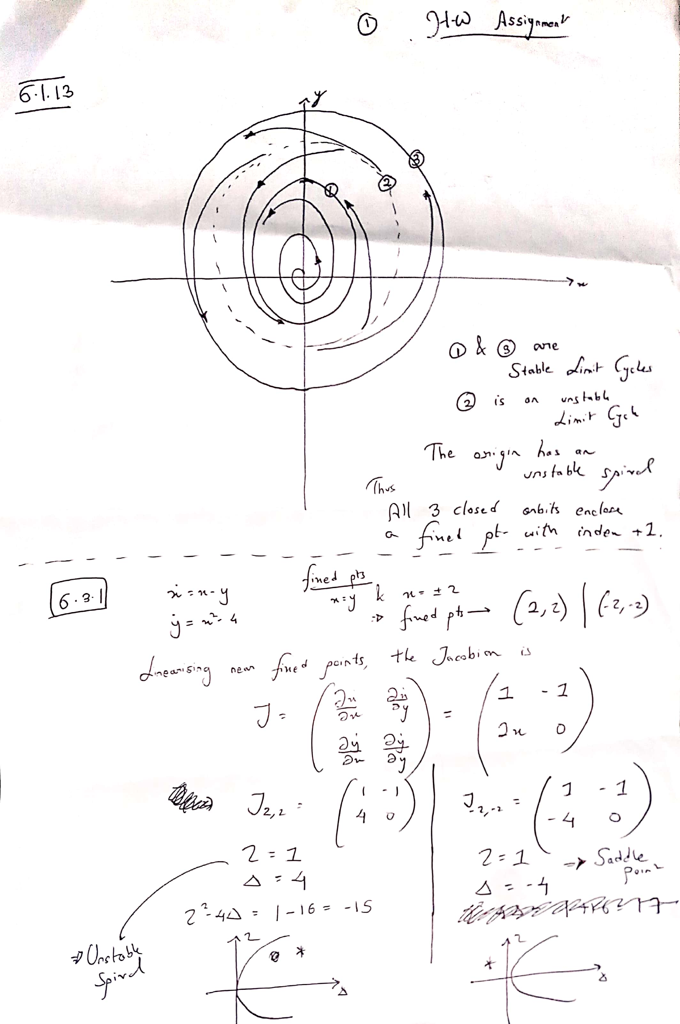

## 6.3.1

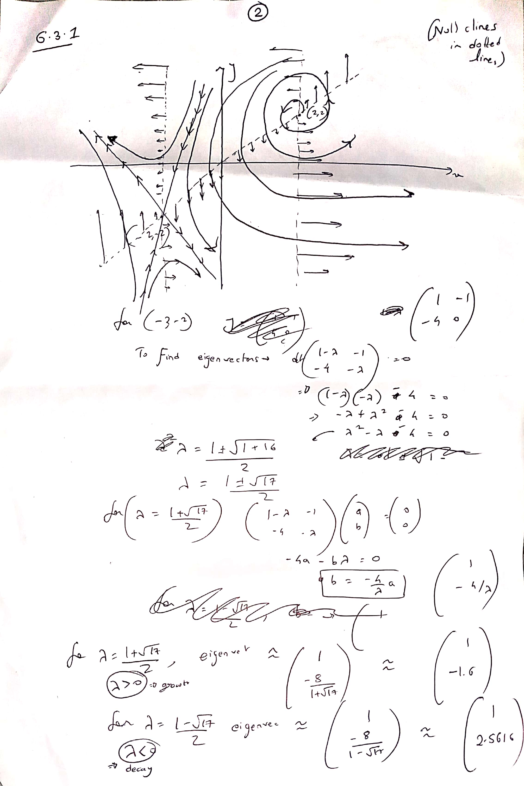

## 6.3.9 and 6.8.5

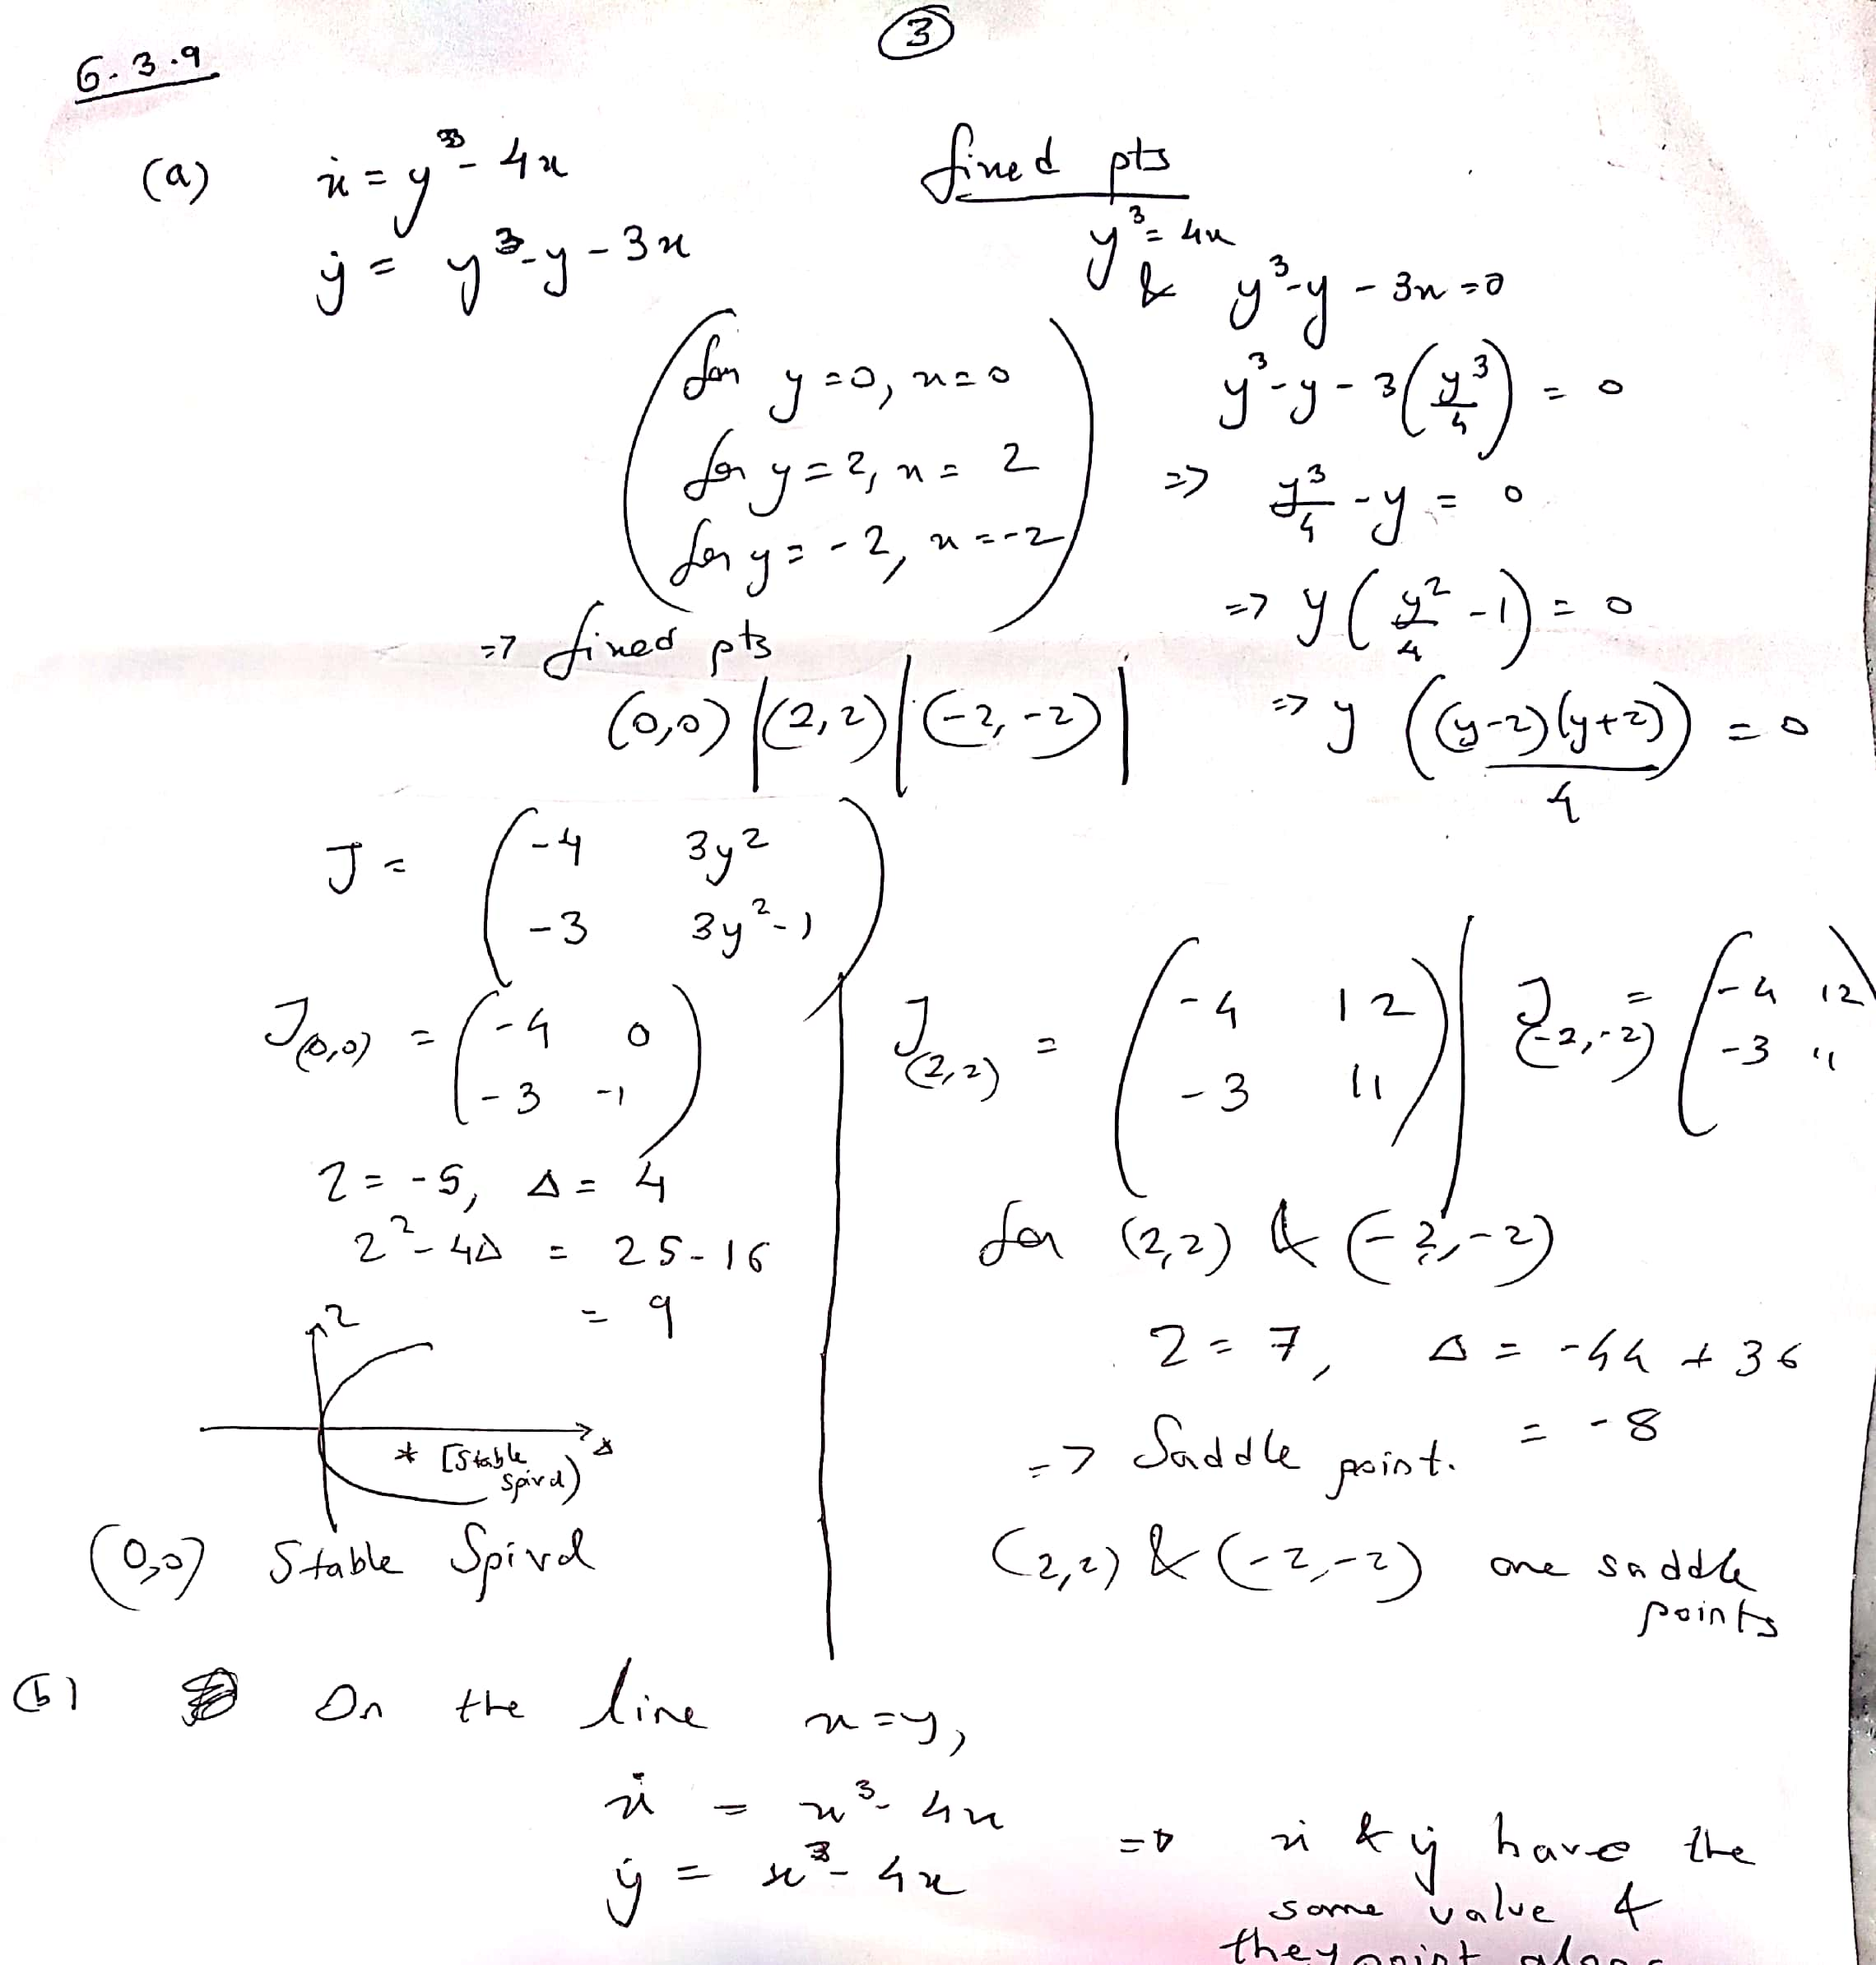

X dot and y dot have same value and they point along the same direction. Hence x=y is an invariant line. All vectors lie along the line itself

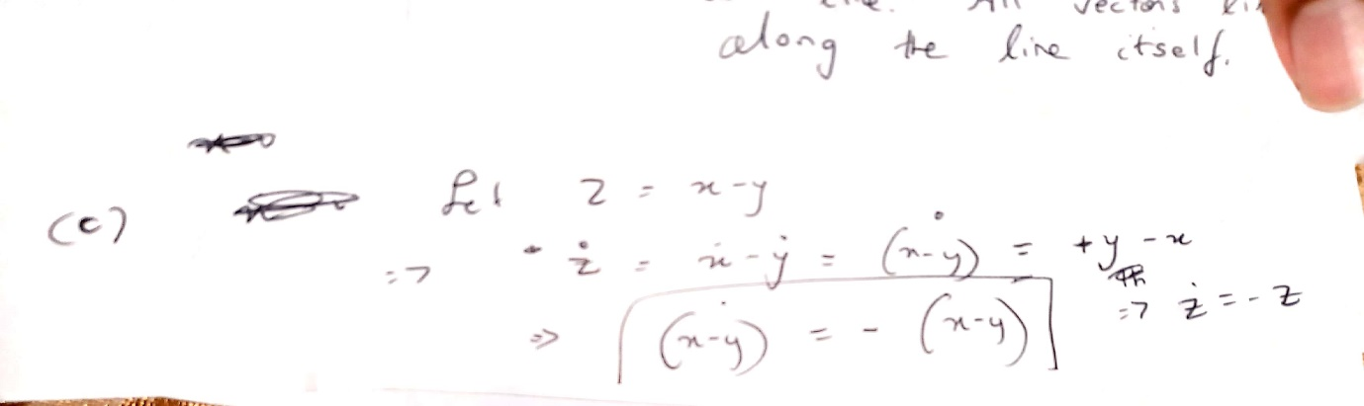

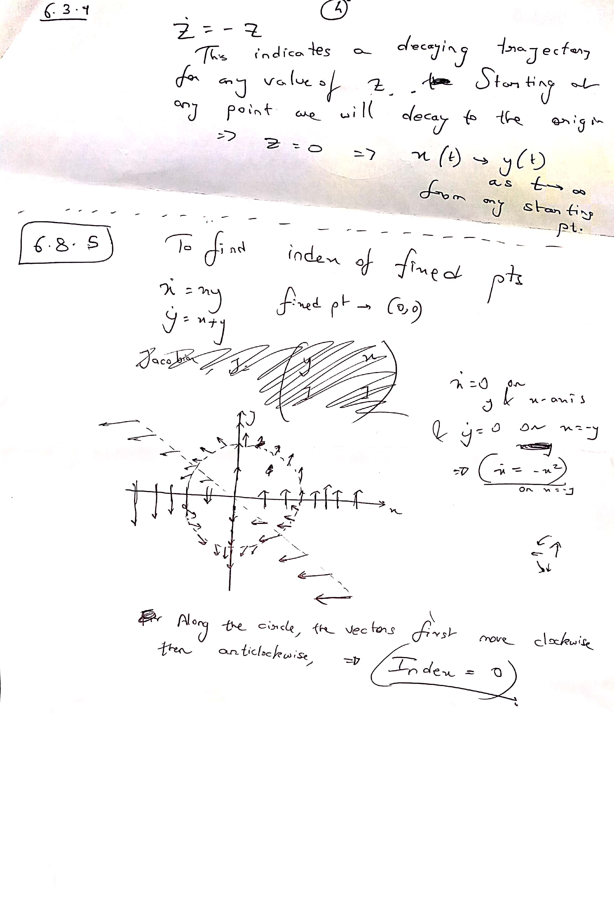

## Homework on Glycolytic Oscillator a=0.08 b = 0.6

In the plot below the blue circles indicate starting points and boxed indicate end points

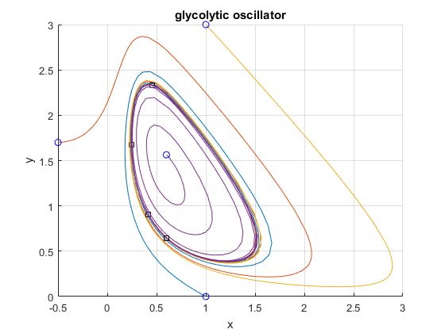

## Time evolution of Volume in Phase Space and stability of origin in Lorenz equations

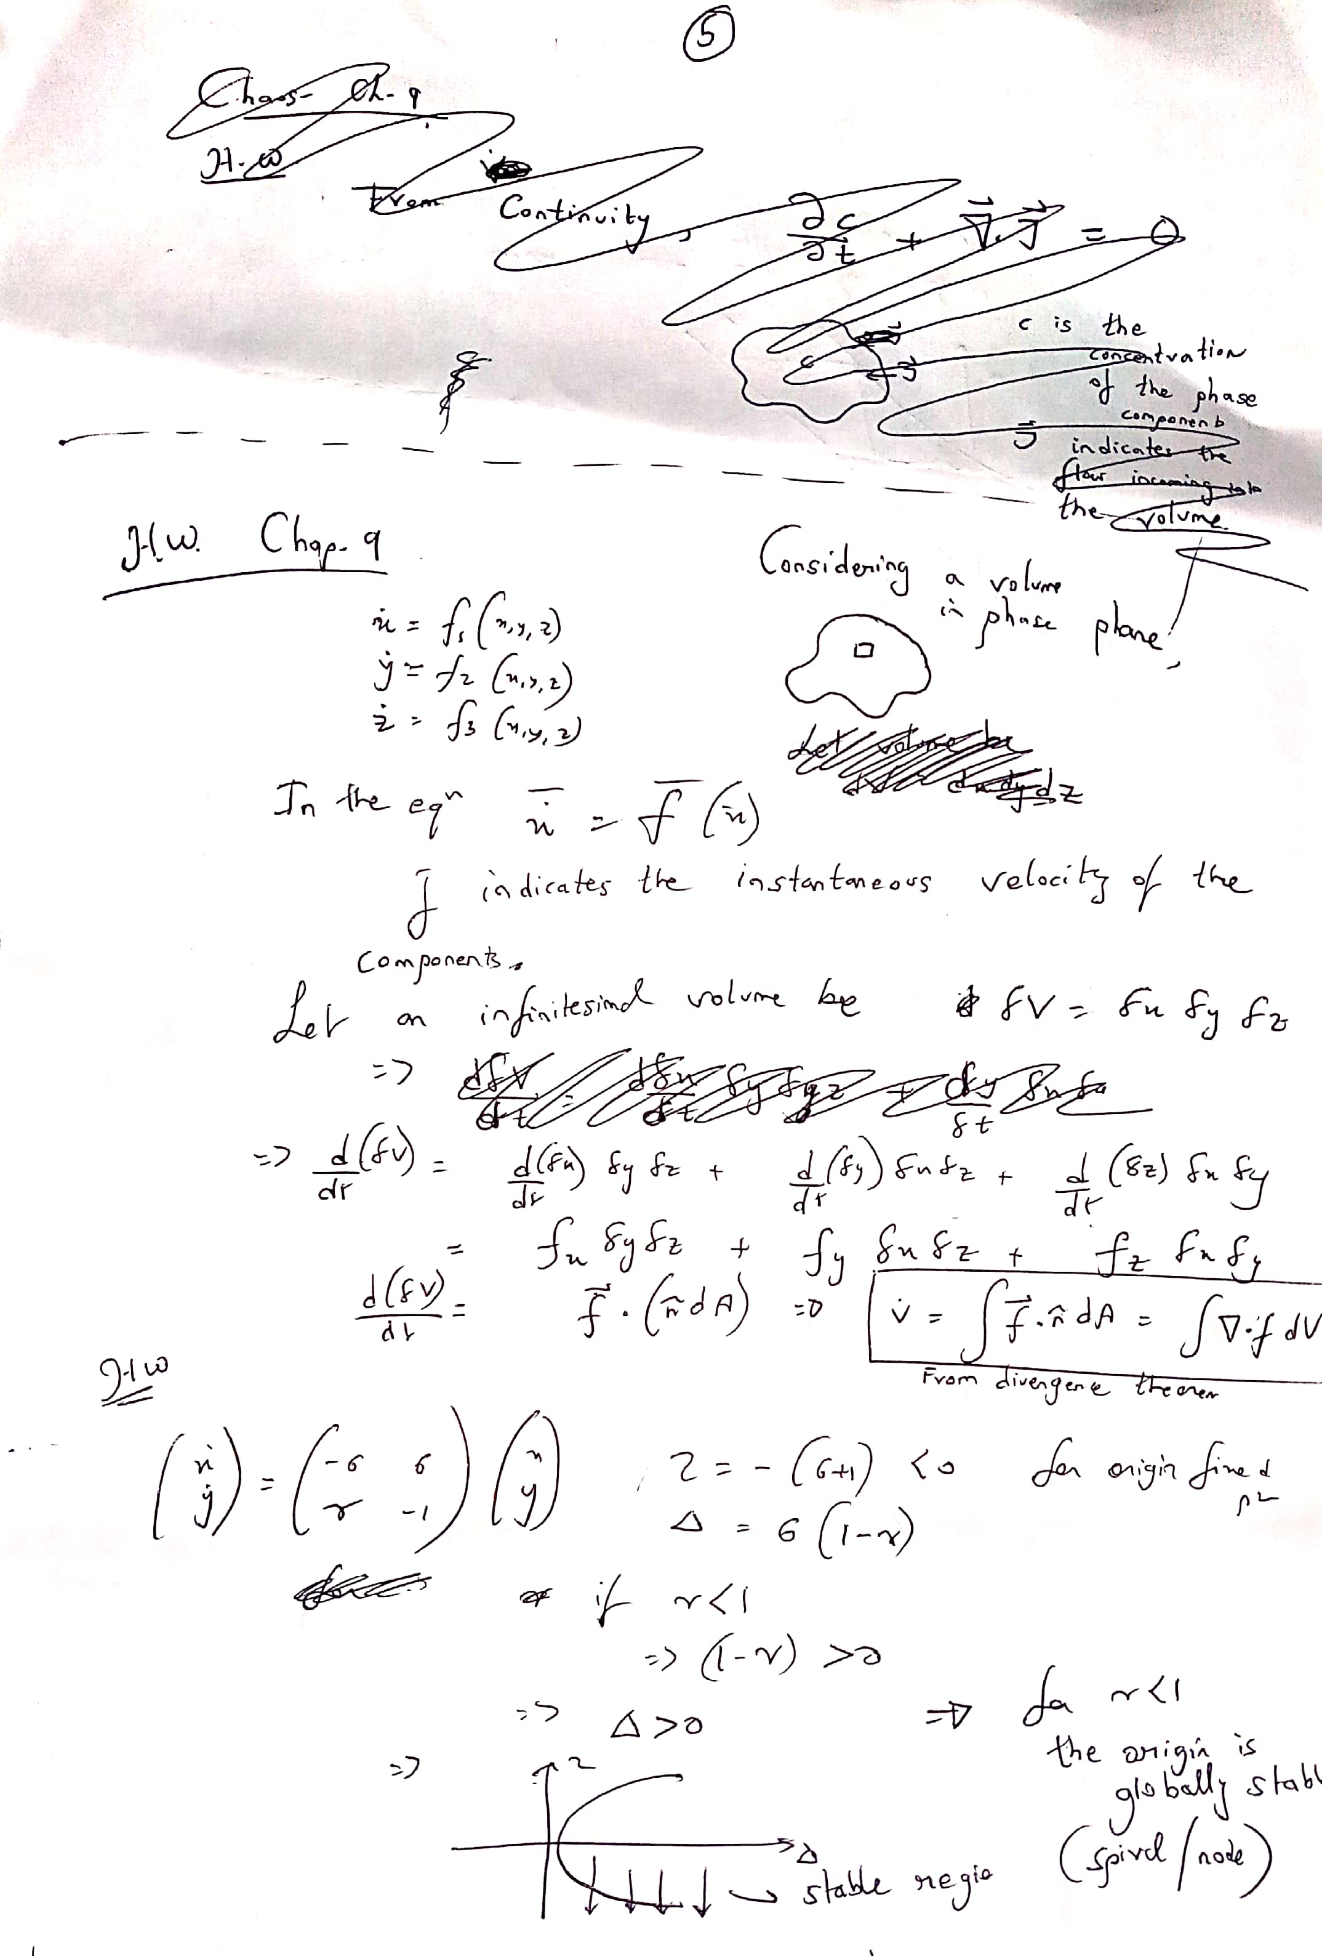

## Chaos on Strange attractor (fig 9.3.1 and Butterfly pattern)

**Fig 9.3.1**

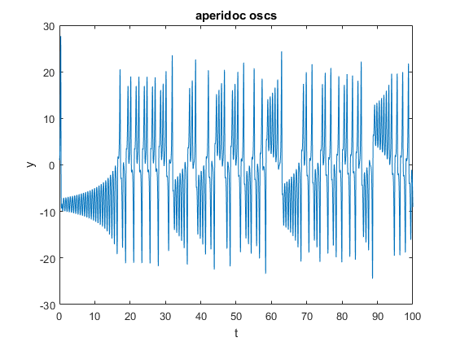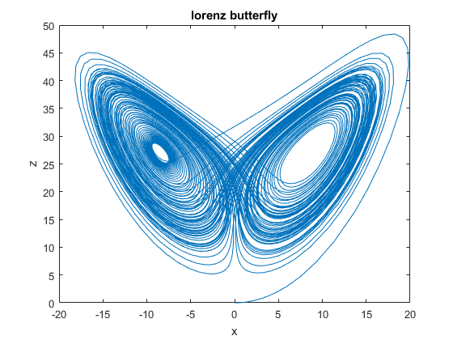

## Homework on Cobweb construction Fig 10.1.1 and Fig 10.1.2

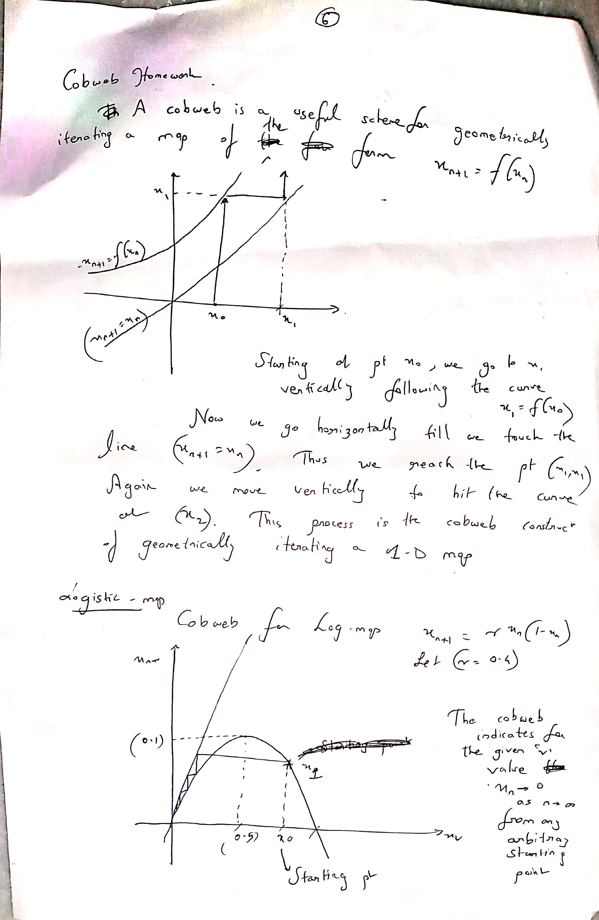

## Plots on the Logistic maps for various values of r as indicated in plots

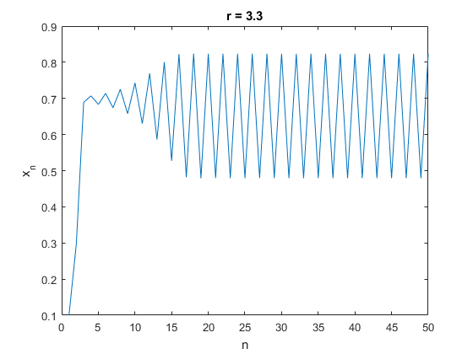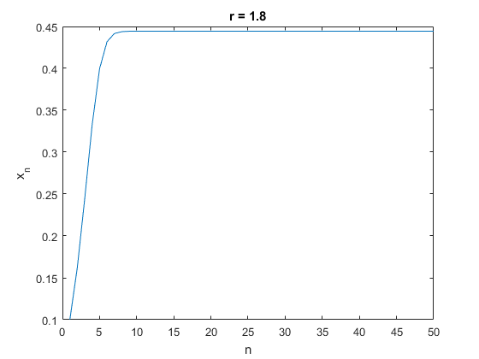

Homework on Cobweb construction Fig 10.2.6 and 10.2.7

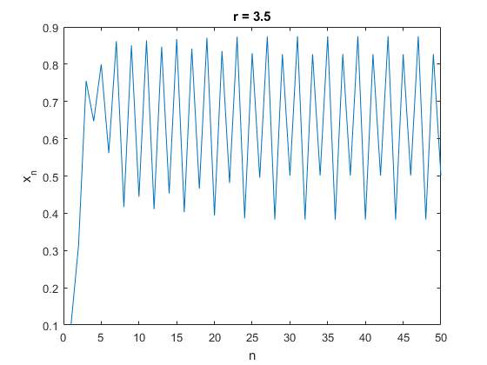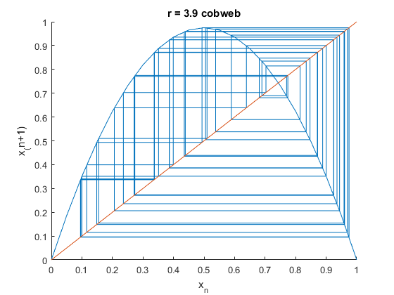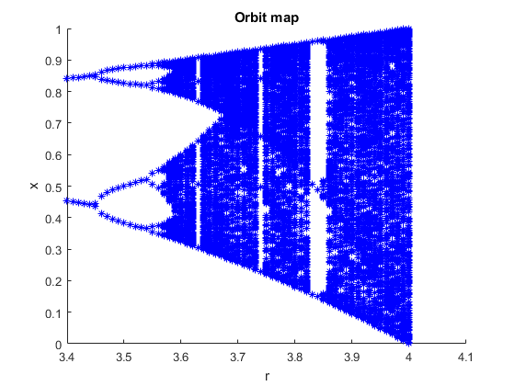

## Homework on values of r for 2 cycle iterations of Xn

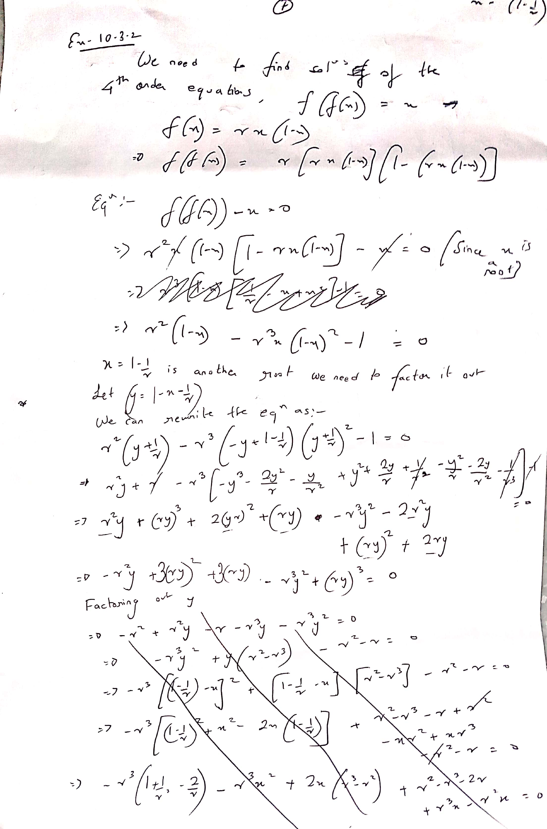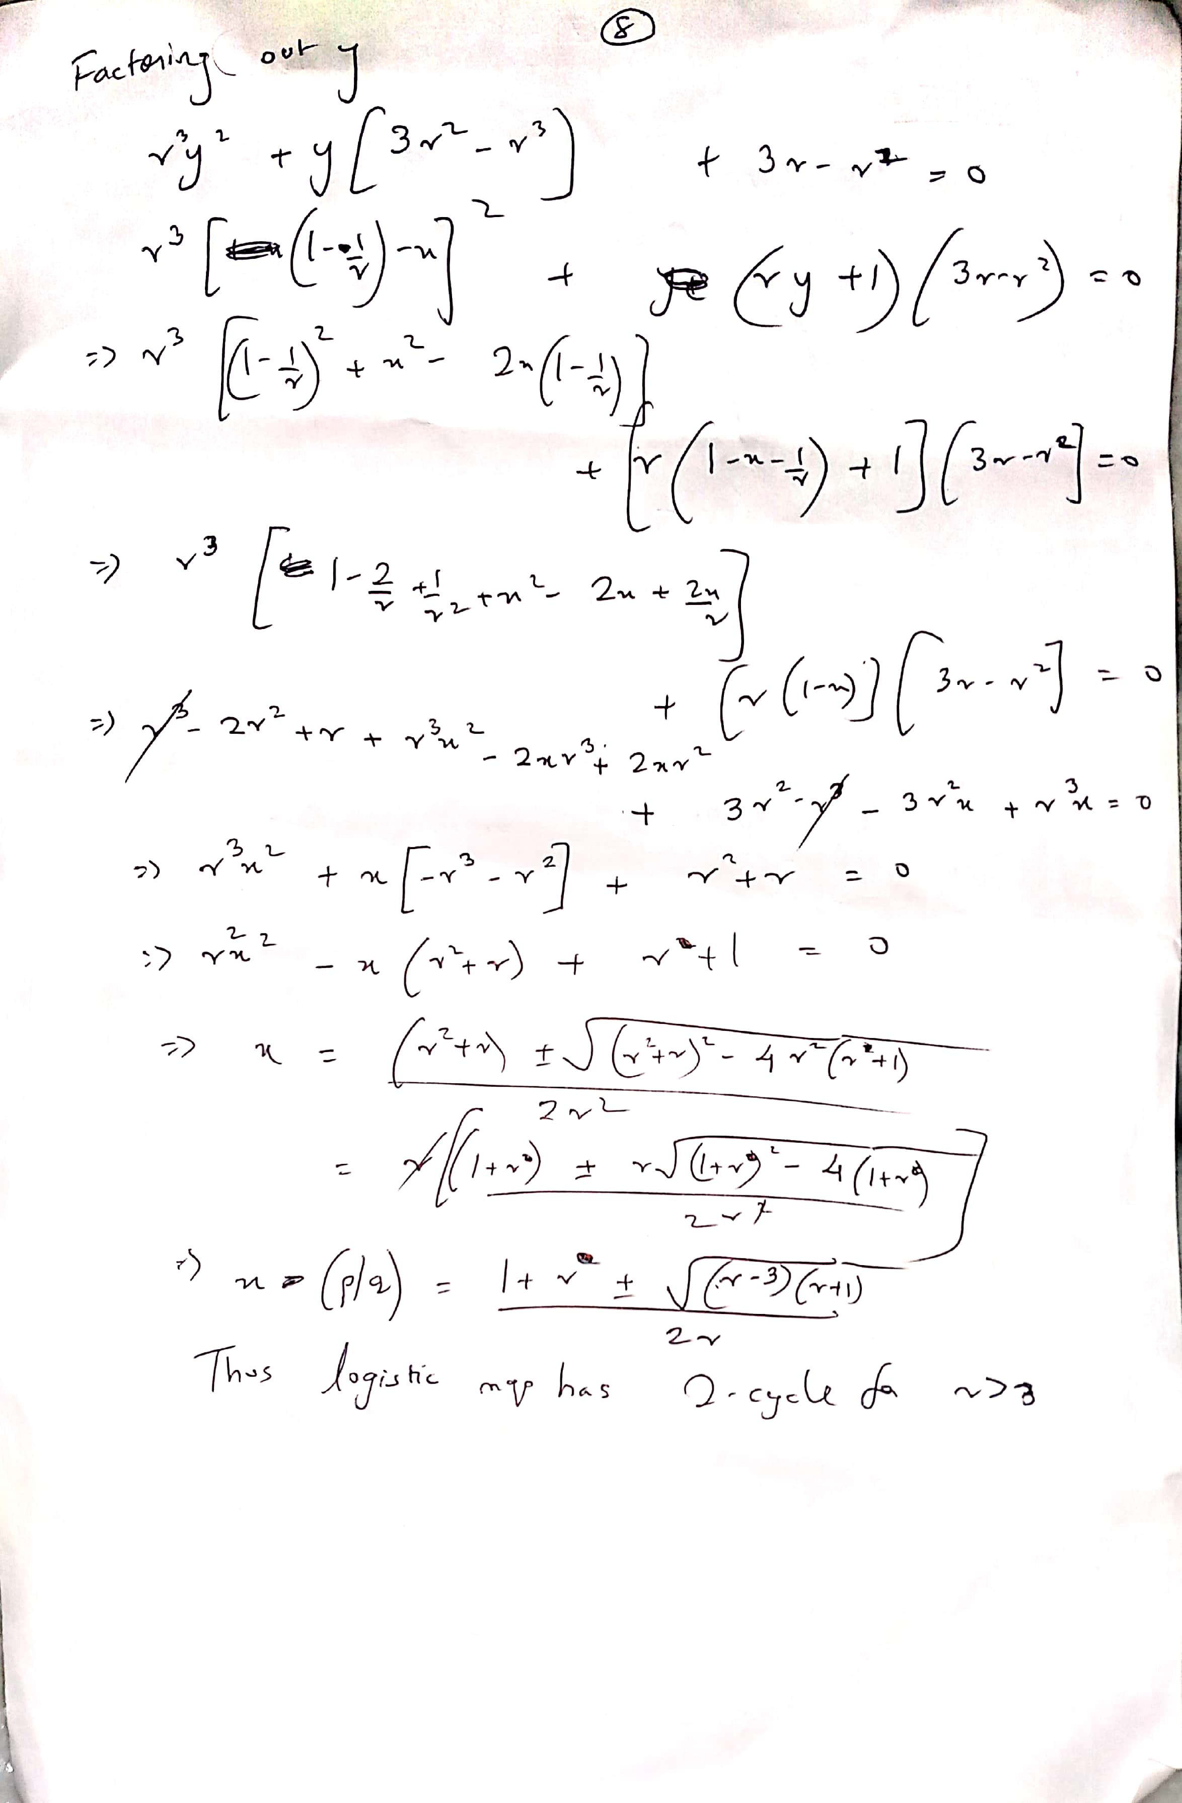

## Homework on 3 period window

The point of tangential bifurcation lies somewhere between r = 3.8 and 3.8.5 as indicated in plots

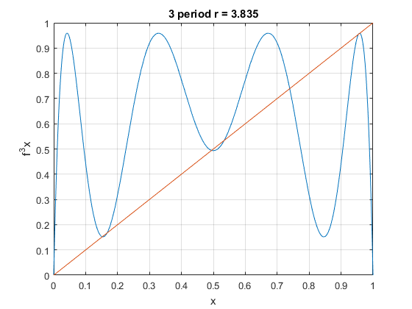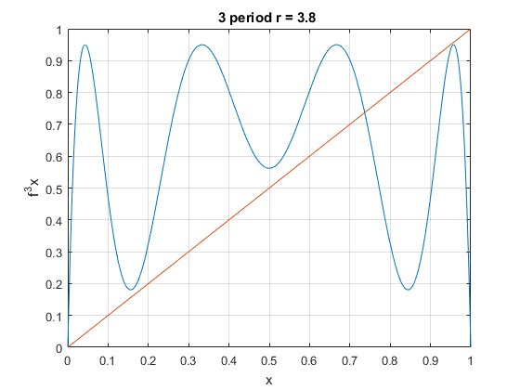

## Homework on Liapunov exponent for Tent map

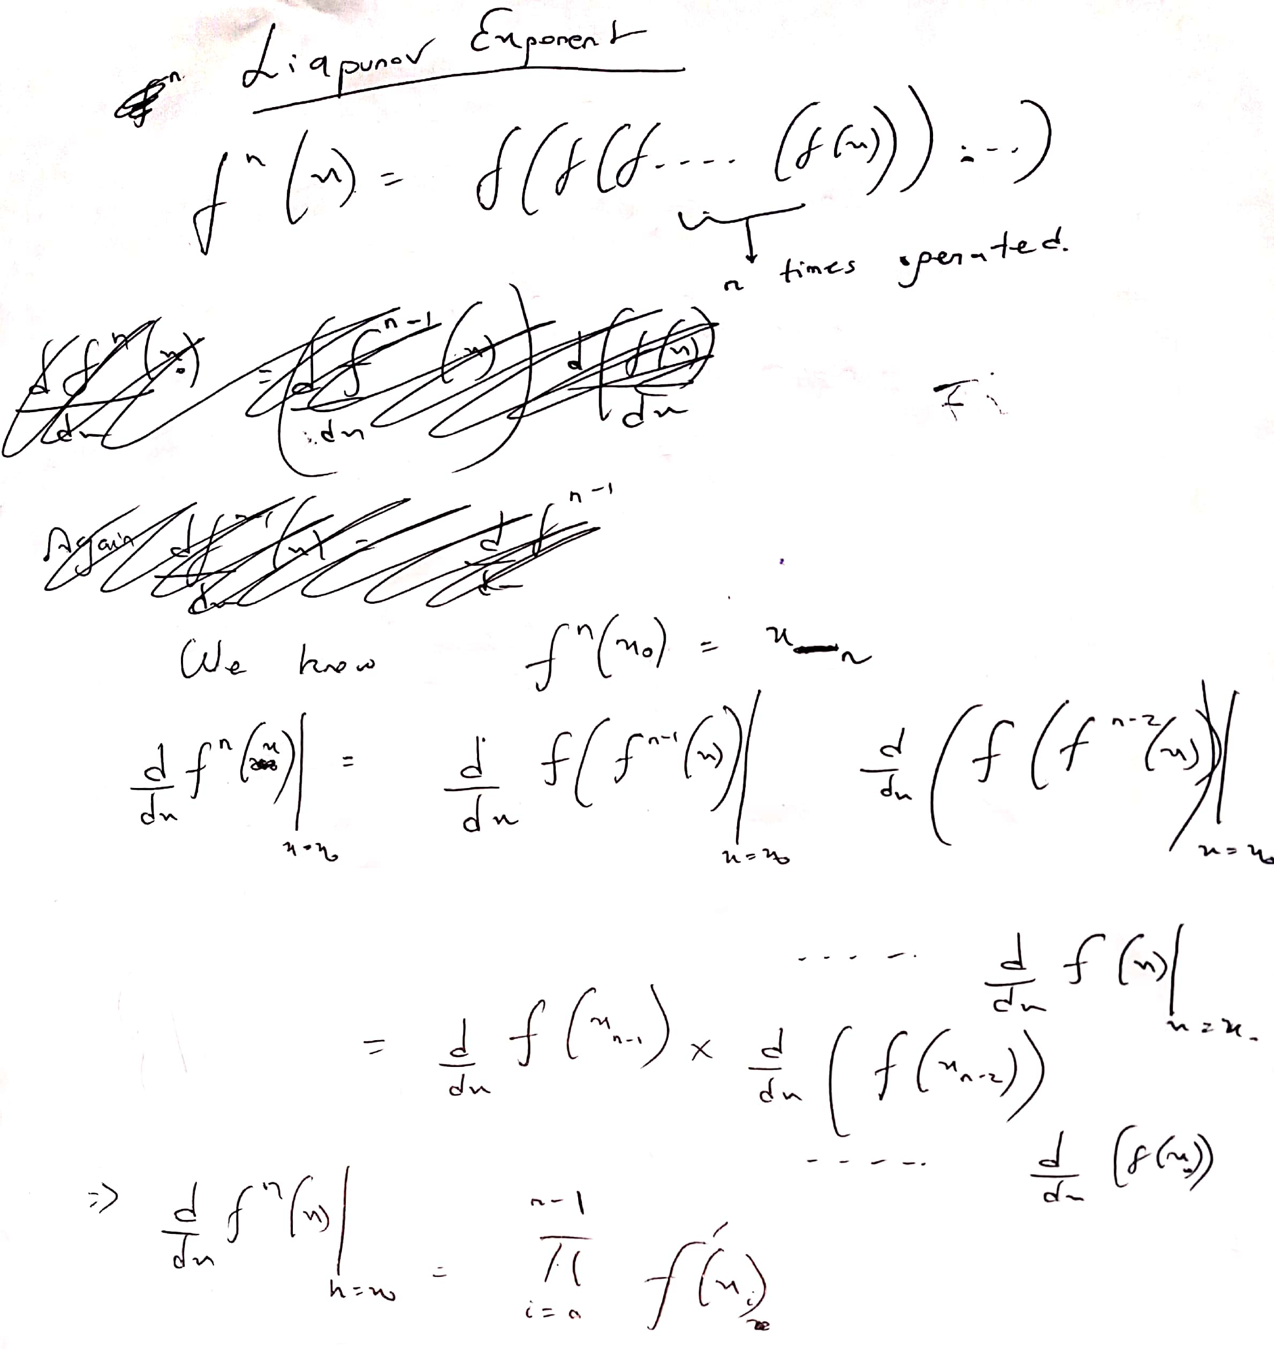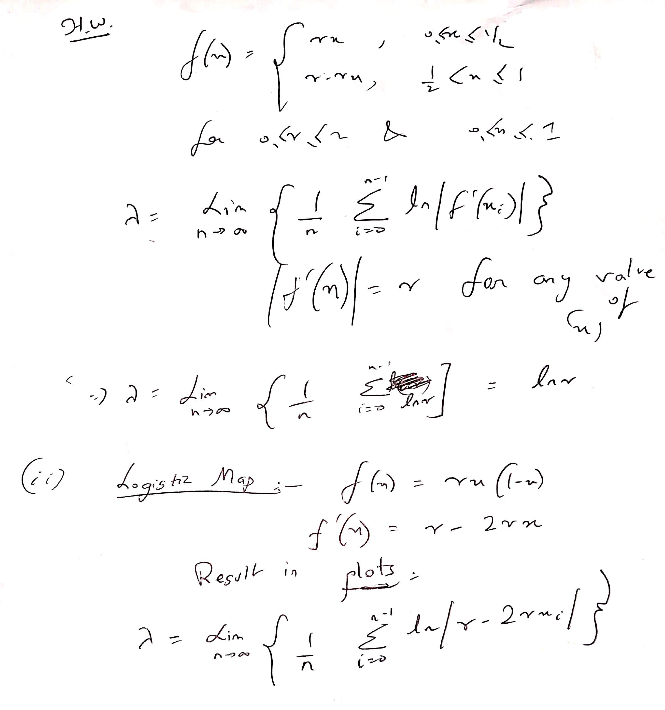

## Homework on Liapunov exponent for Logistic Map

R lies between 3 and 4

